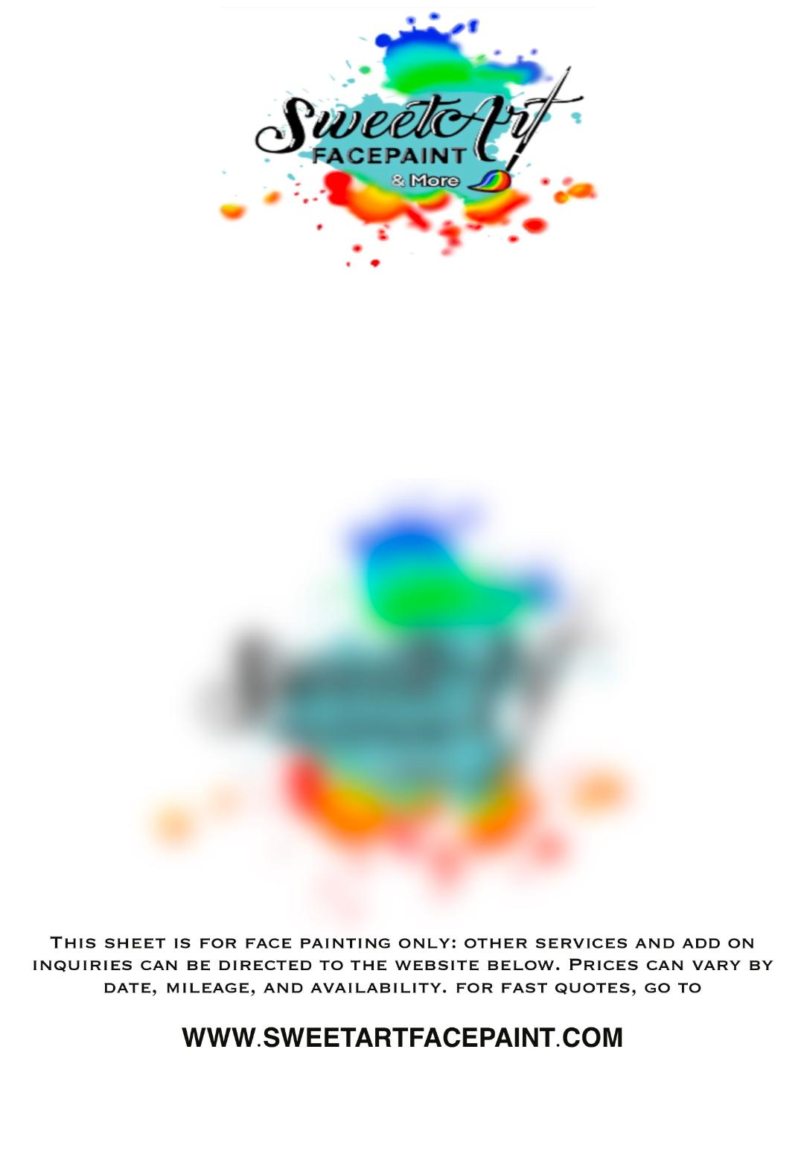

**Contract & Service Agreement**

Please note that quotes expire after 24 hours. Bookings are secured when confirmation AND deposit

are received. Communicate that more time is needed so that arrangements can be made; otherwise,

unsecured dates and times are considered available to other inquiries. Deposits are non-refundable. In the

event you must cancel, deposits are transferable to a future available date within a year of the initial

cancelled date.

SweetArt FacePaint is a Veteran professional event service that fully commits to our obligations. We

are unlike other small businesses in the sense that once your event is booked, there is no need to

constantly crowd our inboxes to ‘check in’ and repeatedly confirm your booking. Please avoid these

unneccesary messages that delay our communication with other inquiries and possible time sensitive

messages.

We arrive at events up to 15 minutes prior to set-up so we can be ready to start at your booked time.

Please have a designated area you would like us to be in out of the way of guests and foot traffic. In

addition, we would appreciate the notice if we will be working outdoors. Changes and cancellations

should be forwarded to us immediately, at least 24 hours prior, to avoid conflictions or loss of deposit.

SweetArt FacePaint contributes to good times and smiles: we do not require unhappy guests to be

painted. Please do not force anyone to get their face painted. Furthermore, those wanting face paint, and

any other service, must be willing to sit still, have their hair out of the way, with a clean face. Being ready

for your artist to work allows more time at your event for us to do more of what we’re hired to do. Sorry,

we can not paint sick children or over abraisons, cuts, sores, etc. Arm paints can be done to accommodate.

We have the right to refuse service to anyone and terminate any involvement in events that include

participation by other face painters not affiliated with SweetArt FacePaint. We require a full refund of any

fees we have paid, when other face painters are, knowingly or unknowingly, present and working.

This avoids conflicts and confusion with competeing brands and mitigates work done outside of our quality

and practice to be affiliated with us, along with any other negative associations with other face painters.

SweetArt FacePaint uses professional grade, hypoallergenic paints and latex free hygenic supplies.

There is always a possibility of exposure to allergens: participation in our services is voluntary and should be

avoided if you have any allergies, illnesses, or any other ailments.

SweetArt FacePaint will not be responsible or held liable for any adverse reactions that may occur.

Participation in our services should be done under your own recognizance, as you are liable for any impact

on your affiliated entity as a whole, yourself, and others. Agreeing to this contract is done so by selecting

the box in order to receive a quote and book.

**www.sweetartfacepaint.com**

*SweetArt FacePaint 2023*